S3 (Simple Storage Service)

It is object oriented. Means it stores the objects inside S3

We create containers. They are called buckets

When we host a website in something like GoDaddy, we can’t get large enough storage

Also, if we copy any file contains virus to the server which may affect the whole server

So, here S3 will be useful

S3 cannot understand what type of file we are keeping, it is just a box where we can put and retrieve whenever we want. That is called objects

This is most useful in WORM (write once read many times) operations

We create bucket and we can have a security policy to have it either public or private

We give the link to this bucket inside the server

This can be accessed from any where

Create a bucker in S3 service, then we can add files and create folders

After uploading the file, we can see the link to access the file

By default, we don’t have access to that, to make that public, we need to select make public option as below



Now we can have access to that and we can give the link in server

Like this we can create S3

If we want to share a file between servers in a cluster, we need to use EFS (Elastic File System)

While creating the ec2 instances, we can use user data as below

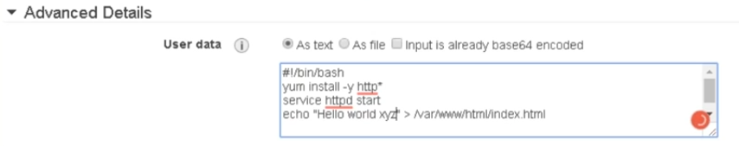

We can add file or text to do some operations at the time of booting the machine

We can create volume and assign it to the instance as below if we want to add a disk to the server

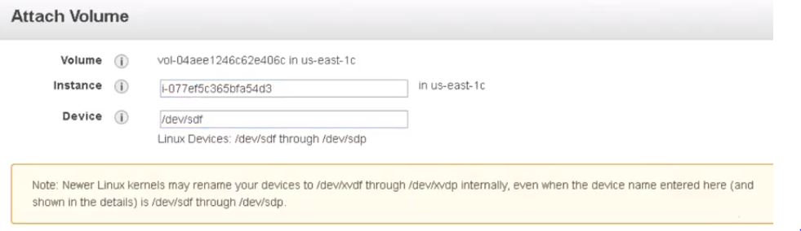



We can use SCP as above also

Lsblk

Fdisk -l

* Partprobe 🡪 is the command to refresh hardware configuration

Autoscaling:

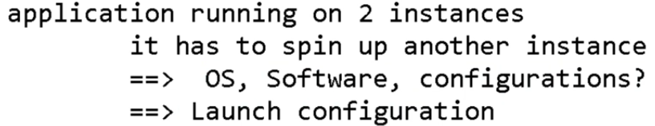

Before changing the autoscaling policy, we need to set launch configuration like what kind of AMI we use and configuration we use

